Exercise 1: Logging Error Messages and Warning Levels
Task: Write a Java application that demonstrates logging error messages and warning levels
using SLF4J.
Step-by-Step Solution:
1. Add SLF4J and Logback dependencies to your `pom.xml` file:
<dependency>
<groupId>org.slf4j</groupId>
<artifactId>slf4j-api</artifactId>
<version>1.7.30</version>
</dependency>
<dependency>
<groupId>ch.qos.logback</groupId>
<artifactId>logback-classic</artifactId>
<version>1.2.3</version>
</dependency>
2. Create a Java class that uses SLF4J for logging:
import org.slf4j.Logger;
import org.slf4j.LoggerFactory;
public class LoggingExample {
private static final Logger logger = LoggerFactory.getLogger(LoggingExample.class);
public static void main(String[] args) {
logger.error("This is an error message");
logger.warn("This is a warning message");
}
}

Code :
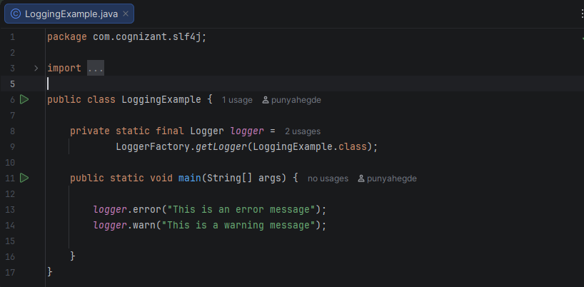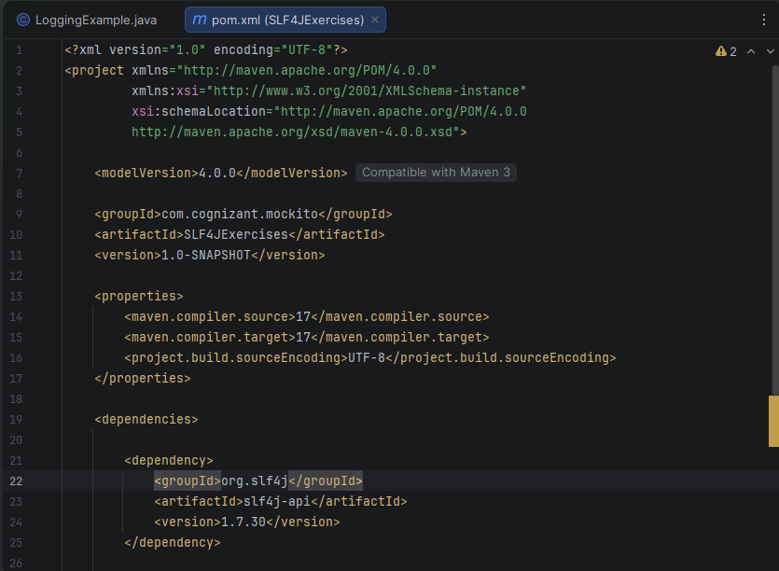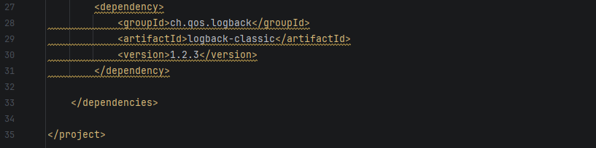
Output :
